SIMATS ENGINEERING
Department of Computer Science and Engineering

ASSESSMENT TOOL 2 – DEBUGGING & OPTIMISATION TASK

Course Code: | CSA12 | Course Title: | Computer Architecture
CO Assessed: | CO2 – Precision (BL3) | Assessment: | Debugging and Optimisation task
Weightage: | 45% | Total Marks: | 100
CO2 Statement: | Apply integer and floating-point arithmetic algorithms including Booth's multiplication, restoring/non-restoring division, and IEEE 754 standard operations to solve fixed-point and floating-point computational problems.
Student Name: | S Lakshmi priya | Reg. No.: | 192524284
Section / Batch: | AI&DS | Date: | 05/08/2026
Instructions to Students
- Identify arithmetic errors and performance bottlenecks in the given problem.
- Analyse the execution steps to locate the source of errors.
- Debug the algorithm by correcting logical and computational faults.
- Optimize the solution using appropriate arithmetic techniques or algorithms.
- Evaluate the optimized solution for correctness, accuracy, and efficiency.

QUESTIONS
- A computer system performing signed binary subtraction using 2's complement produces incorrect results for certain operand combinations. Debug the subtraction process by examining binary conversion, complement generation, and overflow detection. Suggest appropriate corrections to ensure accurate signed arithmetic.
- A digital processor implementing a carry look-ahead adder fails to produce the correct sum for some input combinations. Debug the generate and propagate logic to identify the source of the error. Recommend modifications that restore correct operation while maintaining high-speed performance.
- A hardware multiplier using Booth's algorithm consumes more clock cycles than expected during signed multiplication. Debug the execution sequence by analyzing bit-pair decisions, arithmetic shifts, and register updates. Propose optimization techniques to improve execution efficiency without affecting accuracy.
- A processor implementing the non-restoring division algorithm produces incorrect quotient values for specific dividend and divisor combinations. Debug the step-by-step division process by examining partial remainders, shifting operations, and quotient-bit generation. Suggest corrections to obtain accurate division results.
- A graphics processing application experiences performance degradation due to frequent floating-point computations using IEEE 754 double-precision representation. Debug the arithmetic operations to identify unnecessary precision or computational overhead. Recommend suitable optimization techniques to improve execution speed while maintaining the required numerical accuracy.
Code of Conduct
I s Lakshmi priya(192524284)(Name / Reg No) certify that this submission is my original work and that I have adhered to the guidelines specified for this assessment. I understand that any violation of academic integrity rules will result in disciplinary action.

Signature of the Student: s priya
RUBRICS FOR CALCULATION

Criteria | Weightage(%) | Level 4 – Exemplary (5 Marks) | Level 3 –  Proficient (4 Marks) | Level 2 – Developing (2–3 Marks) | Level 1 – Beginning (0–1 Mark)
Identification of Errors / Bugs | 20 | Accurately identifies all errors and issues with complete understanding of the problem | Identifies most errors with minor omissions | Identifies limited errors; misses key issues | Unable to identify errors or misunderstands the problem
Debugging Approach & Analysis | 20 | Uses effective debugging techniques with clear analysis and root cause identification | Applies suitable debugging methods with minor gaps | Uses basic debugging methods with limited analysis | No systematic debugging approach followed
Correctness of Debugged Solution | 25 | Provides completely corrected solution with accurate functionality and expected output | Provides working solution with minor errors | Partially correct solution with limited functionality | Incorrect solution or fails to resolve errors
Optimization Techniques Applied | 20 | Applies efficient optimization methods to improve performance, memory usage and quality | Performs optimization with noticeable improvements | Limited optimization with minimal improvements | No optimization applied or inefficient implementation
Testing and Documentation | 15 | Performs complete testing with proper validation and clear documentation | Provides adequate testing and documentation with minor issues | Limited testing and incomplete documentation | No proper testing or documentation provided

Marks Evaluation:

Q.  No | Identification of Errors / Bugs (20) |  | Debugging Approach & Analysis (20) | Correctness of Debugged Solution (25) | Optimization Techniques Applied (20) | Testing and Documentation (15) | Total (out of 100)
1 | / 4 |  | / 4 | / 4 | / 4 | / 4
2 | / 4 |  | / 4 | / 4 | / 4 | / 4
3 | / 4 |  | / 4 | / 4 | / 4 | / 4
4 | / 4 |  | / 4 | / 4 | / 4 | / 4
5 | / 4 |  | / 4 | / 4 | / 4 | / 4
 | / 20 |  | / 20 | / 25 | / 20 | / 15 | / 100

Course Coordinator Faculty Incharge
QUESTION 1
Step 1: Convert the numbers into binary
5 = 0101
3 = 0011

Step 2: Find the 1's Complement of the subtrahend (3)
Invert all the bits of 0011.
0011 → 1100

Step 3: Find the 2's Complement
Add 1 to the 1's complement.
1100
+ 0001
------
1101
So, 2's complement of 3 = 1101

Step 4: Add the minuend and the 2's complement
0101 (5)
+ 1101 (-3)
-----------
1 0010

Step 5: Discard the carry
Ignore the carry on the left.
Result = 0010

Step 6: Convert the result to decimal
0010 = 2
Final Answer:
5 − 3 = 2

No overflow because the result is within the 4-bit signed range (-8 to +7).
Debugging Checklist
Step | Check | Correction
1 | Binary conversion | Use the same number of bits (e.g., 4 bits).
2 | 1's complement | Invert every bit correctly.
3 | 2's complement | Add 1 after taking the 1's complement.
4 | Addition | Add the numbers correctly.
5 | Carry | Discard the final carry.
6 | Overflow | Check if adding two numbers of the same sign gives the wrong sign.
Conclusion
To ensure accurate signed subtraction:
- Convert both numbers to the same bit length.
- Find the 2's complement of the subtrahend.
- Add it to the minuend.
- Discard the final carry.
- Check for overflow.
- Interpret the result as a signed 2's complement number.

QUESTION 2

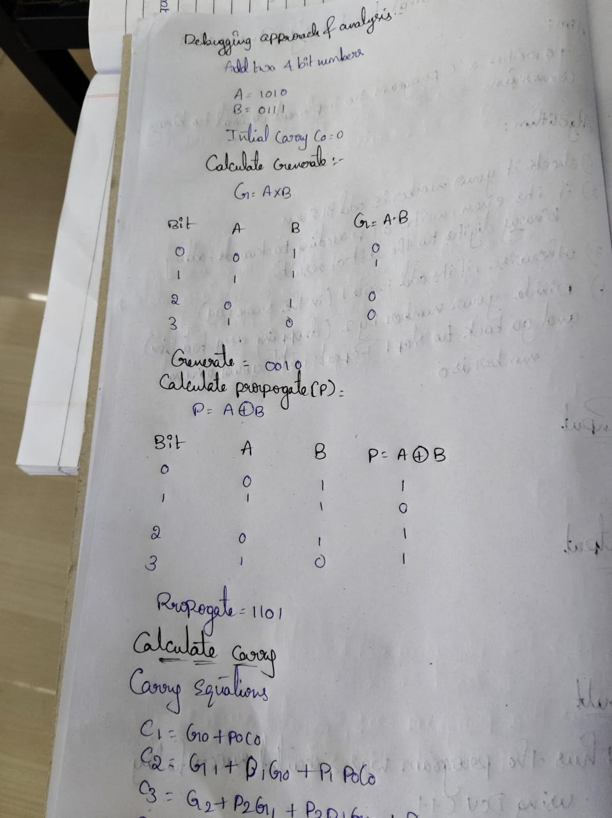

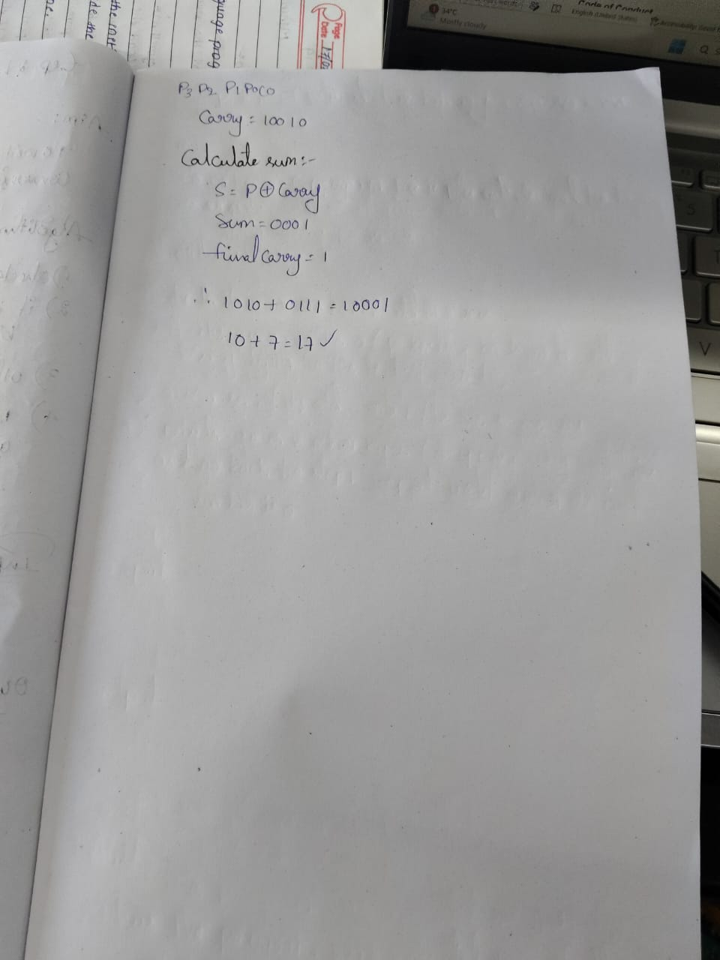

QUESTION 3

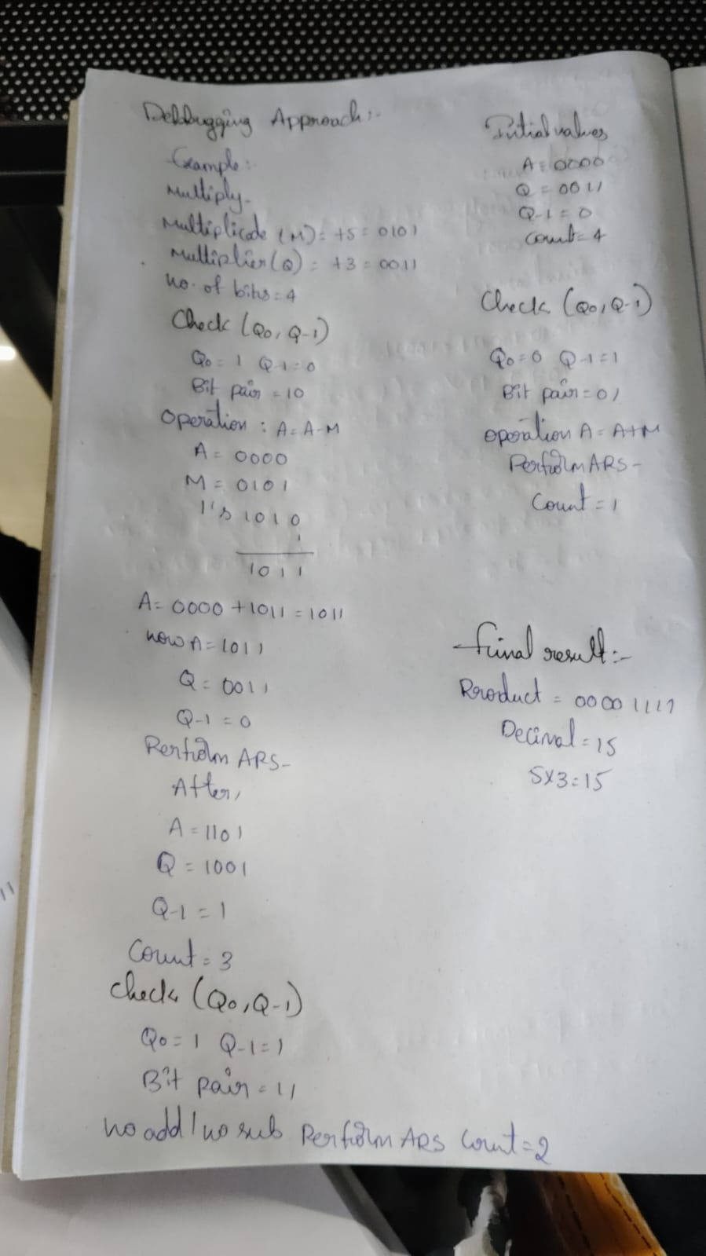

QUESTION 4
Step 1
- Left Shift (A,Q)
- A = A − M (A ≥ 0)
A = 1110
Q = 1010
Q0 = 0

Step 2
- Left Shift (A,Q)
- A = A + M (A < 0)
A = 0000
Q = 0101
Q0 = 1

Step 3
- Left Shift (A,Q)
- A = A − M (A ≥ 0)
A = 1101
Q = 1010
Q0 = 0

Step 4
- Left Shift (A,Q)
- A = A + M (A < 0)
A = 1110
Q = 0100
Q0 = 0

Final Restoration
Since A < 0,
A = A + M = 0001
Final Answer
Quotient (Q) = 0100 = 4
Remainder (A) = 0001 = 1
13 ÷ 3 = 4, Remainder = 1

QUESTION 5

Step 1: Identify the Problem
Graphics application is slow due to frequent IEEE 754 double-precision (64-bit) floating-point operations.

Step 2: Check Arithmetic Operations
- Verify if 64-bit precision is really required.
- Identify repeated floating-point calculations.
- Check unnecessary type conversions (float ↔ double).

Step 3: Find the Overhead
- Double precision uses 64 bits, requiring more memory and computation.
- Frequent floating-point operations increase execution time.

Step 4: Apply Optimizations
- ✔ Use single precision (32-bit float) where high precision is not required.
- ✔ Reduce unnecessary floating-point calculations.
- ✔ Avoid repeated conversions between float and double.
- ✔ Reuse previously computed values (caching).
- ✔ Use hardware/GPU floating-point instructions for faster execution.

Final Result
- Improved execution speed
- Reduced computational overhead
- Maintained required numerical accuracy

